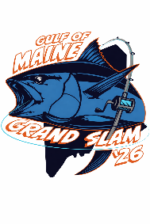
Donation Form
Contact information
Name: _______________________________________________
Business name: _________________________________________
Business address: _______________________________________
City/state: _____________________________ zip: __________________
Email: ______________________________________
Phone: __(___)_________________________________
Donation: ___ Cash or check ___ Gift Certificate ___ Other (describe below)
Estimated or Actual Value: $ _________ (Please use retail value for donated items.)
Description of item donated: _______________________________________________
_______________________________________________________________________

Level of sponsorship (check one)
___ Diamond ($1,250 minimum)
___ Platinum ($750 minimum)
___ Gold ($250 minimum)
___ Other
Important: Diamond level sponsorship includes the option to be a title sponsor for the “Heaviest Tuna” caught in 1 of the 3 participating tournaments by a vessel registered for the Grand Slam. Diamond proceeds will go toward this award. Sponsorship also includes additional social media posts and company logo added to the Grand Slam posterboard for the applicable tournament. If there are more than 3 Diamond sponsors, the option to sponsor the “Heaviest Tuna” award will be given in order of sponsorships received. All sponsor levels will include dedicated social media posts, logo posted on GMGS website and complimentary swag items. Please e-mail ad copy and a high-resolution digital image of your logo or finished banner design.
E-mail: gulfofmainegrandslam@gmail.com

Please mail or e-mail completed form and check payable to Casco Bay Bluefin Bonanza ATTN Gulf of Maine Grand Slam to: Casco Bay Bluefin Bonanza, 727 Poland Range Road, Pownal, ME 04069
Casco Bay Bluefin Bonanza is a 501(c)(3) charitable organization and sponsorships/donations for the Gulf of Maine Grand Slam will be processed through the Casco Bay Bluefin Bonanza 501(c)(3).

